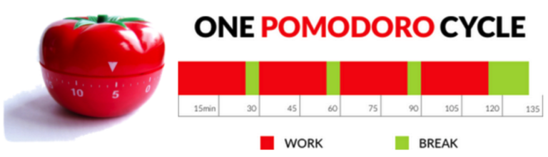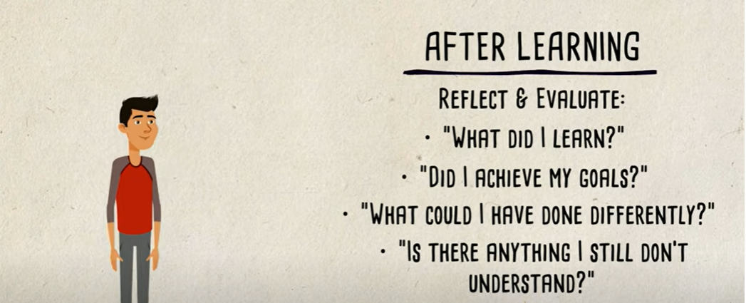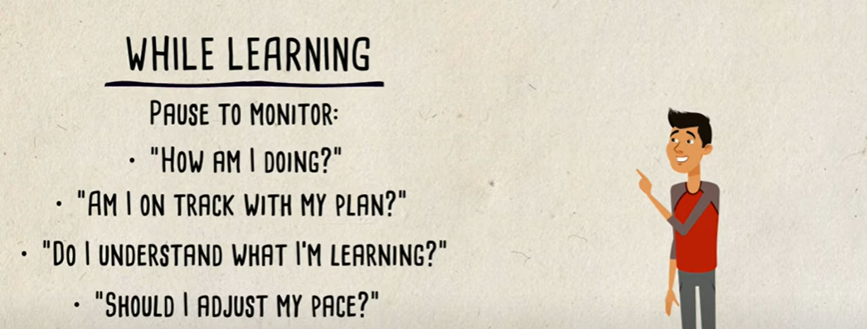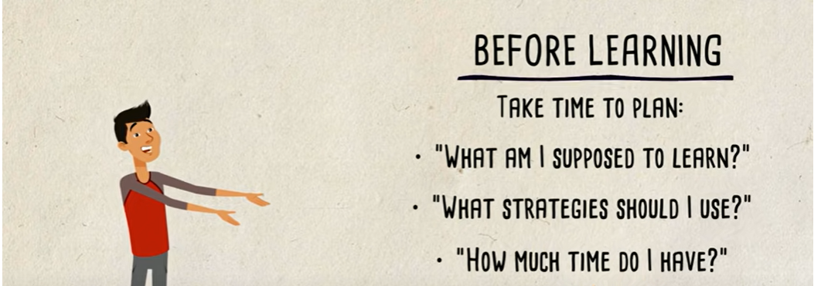

USEFUL WESBITES

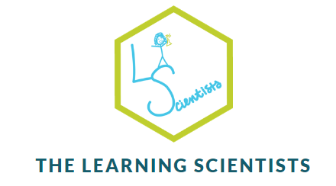

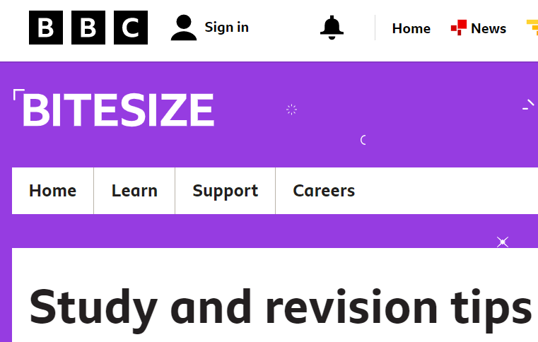

Time management

**REVISION TIPS**

METACOGNITION



**Strategies**

1.**Feynman technique** – learning through teaching

2.**Spaced practice** -**review, practice, recall, formulate and synthesize the same materials multiple times.**

3.**Interleavin**g - mixing together different topics or forms of practice, in order to facilitate learning.

4.**Elaboration** - process of connecting or associating ideas or concepts in a meaningful way.

5.**Retrieval practice** - engage with the material in an active way rather than passive learning i.e. testing knowledge.

6.**Concrete examples** - a way to make an abstract idea more meaningful

7.**Dual coding** - Using visuals alongside information